North Lincolnshire Council
Daily Event Analysis
10th October 2010

Overview
The Dawes Lane Coke Oven (DLCO) Osiris measured a daily mean PM₁₀ concentration of 62µg/m³ on Sunday the 10th October 2010 exceeding the allowed 50µg/m³ as a daily mean. A check of the data has revealed that concentrations of PM₁₀ were above the objective throughout the day. During this 24 hour period concentrations at the Dawes Lane Coke Oven Osiris remained at around 60µg/m³. The Low Santon TEOM measured a daily mean concentration of 40µg/m³. The TEOM did not measure the same elevated levels that the Coke Oven Osiris witnessed at any point during the day.

Met Conditions
Consistent NE winds were observed throughout the day. The wind for the 24hr period ranged between 24° and 73°. Wind speeds averaged at 3.7 m/s. The highest wind speed of the day was 5.4m/s in which the concentration of PM₁₀ reached 52µg/m³. No rain was measured throughout the day.

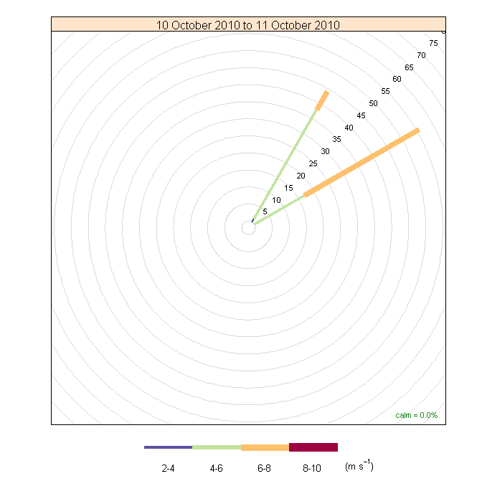

Episode Wind Range

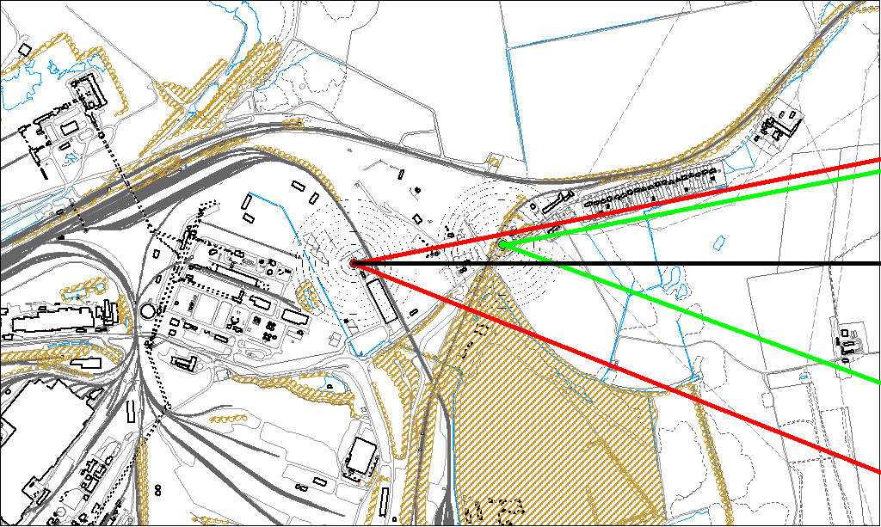

Potential Sources
The above map shows the DLCO Osiris (indicated by the red lines) and the Low Santon TEOM (indicated by the green). The black line within the red shows the wind direction of the highest concentration during the day.

As the TEOM was not subject to the same elevated levels at the Osiris, it is likely that the source of the episode did not originate from within the wind sectors relevant to the TEOM (green lines). By removing the area of the Osiris wind sectors also affecting the TEOM we can identify specific areas on site that may have been responsible for the exceedance.

The likely areas include;

- Tarmac
- Slag Haul Road Entrance

The black line indicates the highest measured concentration during this period. This runs through the Tarmac site.

